A Safe Attitude
Safety is always important, especially when you work with power tools. Machines turn sharp saw blades and cutters at high speeds. Accidents happen so quickly the operator seldom knows what happened. Most accidents are caused by workers who lack the right safety attitude. Workers who do not take safety seriously. Instead of working the safe way, they work the fast or easy way. Instead of being safe, they put everyone in danger.

Machine safety is up to you. Develop a safe way is the best way attitude. Learn all you can about the safe operation of each machine. Listen and watch closely as your instructor demonstrates how to use a machine. Know all the safety rules and the steps for operating each tool.

To operate a machine safely, you must know more than just how to turn it on and off. You must know how to do the basic operations and how to make simple adjustments. You must know the machine’s limits. Keep the machine at a safe, steady speed. Use the machine for the operation it was designed to do.

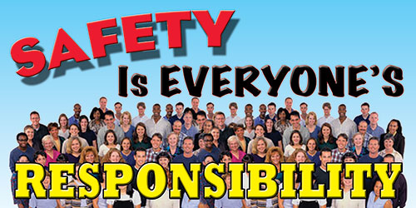
You cannot expect to be an expert on all machines right away. DO NOT EXPERIMENT. If you have a question, ask your instructor. The more you know about a machine, the safer you will be. A machine only does what its operator directs it to do. It can only be as safe as its operator. As you learn to operate a machine, you will gain confidence. Make sure that confidence does not lead to carelessness. This does not mean you should be afraid of machines, a safe attitude is one of respect- respect for what machines can do.

