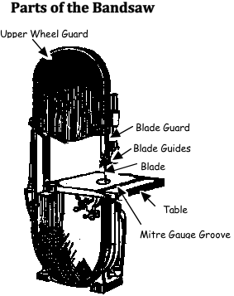 **Bandsaw Use**

**BANDSAW**

The band saw is used to cut irregular shapes, circles and general purpose work. It cannot make cuts as straight as the table saw, nor as sharp as the scroll saw. It cannot make cuts inside a piece of wood like the scroll saw can. It can cut wood much thicker and straighter than the scroll saw and can cut curves better than the table saw.

**Proper Dress**

l. Wear Eye Protection.

2. Remove jewelry. Confine long hair. Eliminate loose clothing.

**Machine Set-Up**

3. Set the blade guard to within 5 mm of the work piece.

4. Make sure all guards are in place when working on the band saw.

5. Check for loose knots, nails and staples before cutting.

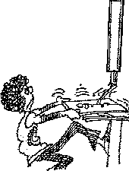**Operation**

6. Keep the wood as long as you can for as long as you can so that you do not cut off possible parts of the wood you can hold when cutting smaller pieces.

7. Use one hand to guide your work and the other to apply even forward pressure when cutting.

8. Keep a margin of safety of at least 5 cm between your hands and the blade when cutting.

9. Turn off the machine and let it come to a complete stop before backing out of a long cut.

10. Make relief cuts when cutting sharp curves.

11. Do not stand or let others stand directly in line with the blade when operating the band saw.

12. If cutting cylindrical stock, clamp it securely or hold it tightly to prevent it from rotating when you cut.

13. Keep your eye on the cutting edge of the blade whenever it is running.

14. If you are doing a new operation that you have not done before such as tilting the table to cut bevels, get your teacher to check your setup before starting.

**Finishing**

15. Stay with your machine until it comes to a complete stop.

16. Make sure the blade has completely stopped before removing scraps from around the blade.

17. Put the guard down and tidy your machine before leaving it.