**Name _____________________________ Class ________ Date Due_______________**

|  |  |  |  |
| --- | --- | --- | --- |
| **Challenge** | **Design and Build a CO2 Car** | **Grade** | **Eight** |
| **Essential Question** | What makes a car go fast? This is Rocket Science! Become the Engineer that designs and builds the fastest “Rocket Car” in the class. | **Estimated Time** | **12 Hours** |

|  |  |
| --- | --- |
| **Challenge Description** | In this challenge you will use the design cycle to construct a CO2 powered race car. You will research, design, construct and race your car within certain limitations. As you go through the design and construction process, **you must check off the steps and get Mr. Bain to initial the checkpoints indicated.** |

**B. Research: visit** [**mrbain.weebly.com**](http://www.mrbain.weebly.com)then choose CO2 cars from Design Studies 8 for information required to complete this task. Mr. C’s Racing resources is an excellent place to start.

1. True False CO2 Cars work on the same principle as dragsters.

2. True False The forces pushing against the walls of the CO2 Cartridge is equal in all directions.

3. True False Understanding the principles of a CO2 Car is rocket science.

4. True False **Drag** is resistance to wind moving over an object.

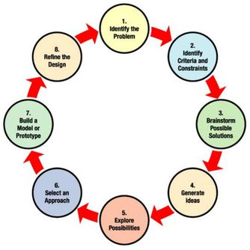5. True False **Areodynamically** “clean” shaped cars go slower than ones that have lots of drag.

6. True False A **heavy** car will be faster than a **light** car.

7. On a CO2 car, **friction** occurs:

a. Between the wheels and the ground.

b. Between the axels and the car

c. Between the eye hook and the fish line track

d. Friction occurs in all of these places

8. True False **Friction** can be eliminated completely from your CO2 car with careful planning.

9. Lift can be described as an **areodynamic** term. How can lift affect the performance of your CO2 car?

10. How does **weight** of the CO2 car effect the size of the hole made by the firing pin?

How does it affect the speed of the car?

11. The fastest Cars will be _________________ in weight, ______________________ in shape and have reduced the amount of _______________________ wherever possible. *Bold Words*

**Design Envelope: You must design within the limits indicated**



|  |  |  |
| --- | --- | --- |
| **Dimension** | **Minimum** | **Maximum** |
| A. Length (without CO2 Cartridge) | 20 cm | 30 cm |
| B. Width at Axles (body only) | 3.4 cm | 5 cm |
| C. Height from floor to highest spot | 6.0 cm | 8.0 cm |
| D. Ground Clearance near axles | 0.8 cm | 1.5 cm |
| E. Distance Between axles | 12.0 cm | 26.0 cm |
| F. Distance from axle to nearest end of car | 2.0 cm | 8 cm |
| G. Distance between eye screws | 12 0 cm |  |
| H Distance from floor to center of Cartridge | 4.5 cm | 5.0 cm |
| Ground clearance | 0.5 cm |  |
| CO2 Cartridge hole Depth | 5.0 cm | 5.0 cm |
| Wood Surrounding CO2 Cartridge | 3 mm |  |

**C. Generate Ideas**

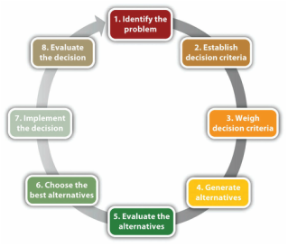Search the Internet and find several shapes and designs of C02 cars that you like the design of and think will be fast. Copy your favorites and paste them onto a **SINGLE** page of a word document**. Print the document and staple it to this design booklet.**

**D.** Select a design or parts of several designs. Describe your **decision making** criteria.

**5. Model the Idea**

**Sketch** an orthographic projection showing the front, and top view of your CO2 car.

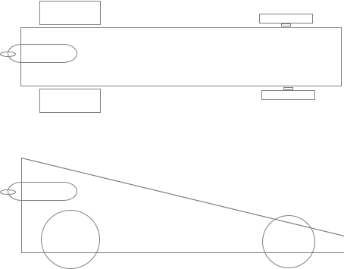

**6. Present your Solution**

Get your friends and teacher to critique your solution

**Name Comments**

________________ _____________________________________________________

________________ _____________________________________________________

____Mr. Bain_____ _____________________________________________________

Do a technical drawing of your final/final/final plan!

**CO2 Car Marking Rubric Name ________________**

**1. Specs: ______/6 Min Max**

* + - Length (without CO2 Cartridge) 20 cm 30 cm
    - Width at Axels (body only) 3.4 cm 5 cm
    - Height from floor to highest spot 6.0 cm 8.0 cm
    - Distance Between axels 12.0 cm 26.0 cm
    - Distance from axel to nearest end of car 2.0 cm 8 cm
    - Distance from floor to CO2 Cartridge center 4.5 cm 5.0 cm

|  |  |
| --- | --- |
| **2. Shaping and Sanding ____/4** | **3. Painting ____/5** |
| * + - Surface free of band saw marks     - Surface free of sanding marks     - Free of unwanted holes, chips and scratches     - Surface is smooth | * + - Paint coat is free of streaks     - No runs in paint job     - No “orange peel” from heavy coat     - Paint job is creative   “Extra” job on stripes, flames, etc. |

**4. Performance _____/10**

* Car makes it 1/5 of the way down the track
* Car makes it 2/5 of the way down the track
* Car makes it 3/5 of the way down the track
* Car makes it 4/5 of the way down the track
* Car makes it 5/5 of the way down the track
* ___/5 1 mark for each win

**Total ______/25**

**5. Career Connections**

Many of the design and construction processes you went through could be tied to various careers that you might interest you in your future.

1. What career could you connect to the knowledge and skills you developed in this challenge.
2. How is that career connected to designing and building a CO2 powered race car?
3. Research and describe the education and training process for the career you described.

