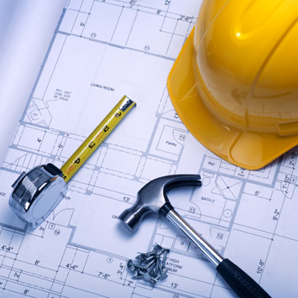
Kevin.bain@gppsd.ab.ca
780-532-1365 ext 2330
mrbain.weebly.com
Are You Up For

Careers and Technology Foundations is a complementary course that challenges you to design and build projects that enhance the learning you are doing in your core subjects. In CTF: Construction and Design, you will acquire, apply and adapt your learning to develop your interests and aptitudes in career related fields and promote working both independently and with others.
CTF is exploring interests, passions and skills while making personal connections to career possibilities
- I explore my interests and passions while making personal connections to career possibilities.
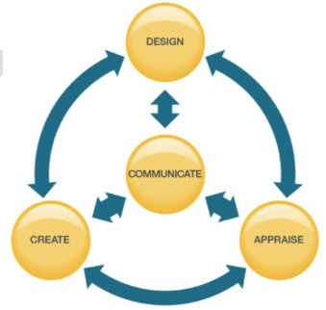
- I use skills/technologies associated with occupational areas.
- I follow safety requirements associated with occupational areas and related technologies.
CTF is designing, creating, appraising and communicating responses to challenges
- I problem solve in response to challenges.
- I design in response to challenges.
- I adapt to change and unexpected events.
- I make decisions in response to challenges.
- I appraise product(s), performance(s) or service(s) created in response to challenges.
- I appraise the skills/technologies I use in response to challenges.
- I communicate my learning.
CTF is working independently and with others while exploring careers and technology
- I describe how my actions affect learning.
- I develop skills that support effective relationships.
- I collaborate to achieve common goals.

Challenges for Alexander Forbes CTF Construction and Design Students
Grade 5 | Grade 6 | Junior Year | Senior Year
Design and Build an Electro-Magnetic Crane | Design and Build an Airplane | Design and Build a Box with a Hinged Lid | Create a poster communicating a Safety Rule
 | Build a model “Delta Dart” Airplane | Design and Build a Wooden Toy Truck | Design and Build an Organizer
 | Design and Build a Boomerang (Airfoil) | Design and Build a project from a list that students can choose from. | Design and Build a project from a list that students can choose from.
 |  | Build a hot dog stick | Design and Build a CO₂ powered dragster.

