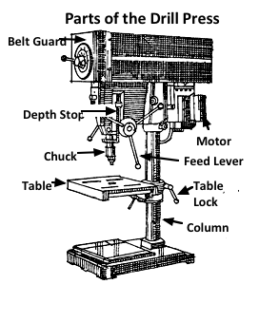 **Bandsaw Use**

**DRILL PRES**

**SS**

The drill press is used to drill holes in wood, plastic or metal. It can be used with attachments and accessories such as drum sanders or mortising jigs for other operations.

**Proper Dress**

l. Wear Eye Protection.

2. Remove jewelry. Confine long hair. Eliminate loose clothing.

**Machine Set-Up**

3. Unplug the drill press to make any adjustments such as changing drill bits.

4. Make certain the drill bit is tightened securely into the chuck using the chuck key. Return the chuck key to its holder when not in use. **Never start the drill press with the chuck key in the chuck.**

**5.** Lock the table to the correct height and position.

6. Make certain the work to be drilled is clamped securely to the table.

**Never attempt to hold wood or metal to be drilled**

7. Adjust the speed according to hole size and material. Use slower speeds forharder material and larger diameter holes.

7. Set the depth stop for the desired cutting depth.

8. Center punch metal to be drilled.

9. Drill a pilot hole first when drilling diameters larger than 3/8” (10mm)

10. Set the depth stop for the desired cutting depth.

**Operation**

10. When using a twist bit or a Forestner bit, remove the bit from the works piece every 1-2 cm to clear the chips from the flutes.

11. When drilling with spade bits, do not come out of the hole as you drill, rather keep the point anchored in the whole throughout the operation, turn off the machine, then remove the bit from the hole.

12. Keep your eye on the cutting edge of the blade

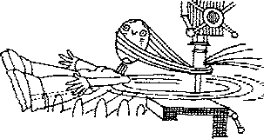13. Do not talk to people while you are using the drill press.

10. Use cutting coolant when drilling steel.

**Finishing**

15. Stay with your machine until it comes to a complete stop.

16. Tidy your machine and put away drill bits when you are finished with them.