Hot Dog Stick Challenge
- Use 3/16” diameter cold rolled steel. Measure a length 60” (5 feet) long
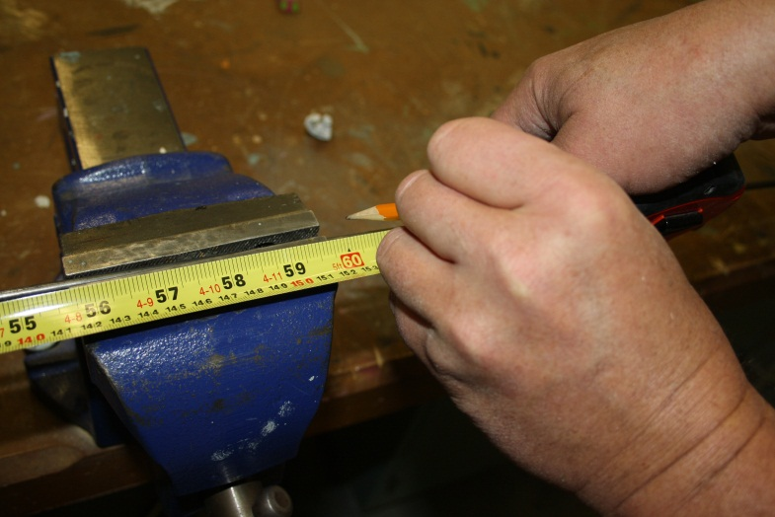

- Keeping your mark very close to the vice, use a hacksaw to cut the steel to length. Cut with long “fluid” strokes.
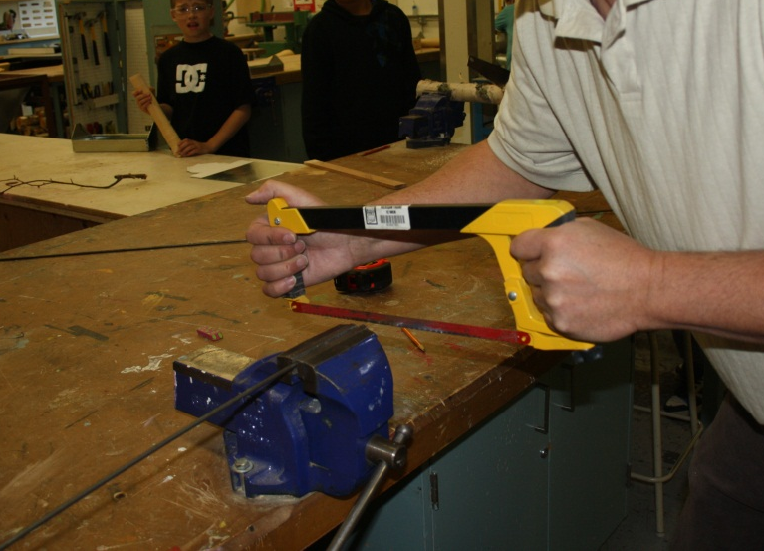
Cut close to the vice so that it doesn’t bend

- Use a file to shape one end to a point (about the taper of a pencil)
Again try to clamp the material close to where you are shaping it.

- Slightly angle the opposite end (this will make it easier to thread a bolt onto it).

- Put away your files and hack saw.

- From the “pointed end” measure in 5” and 15” mark your metal with a marker.
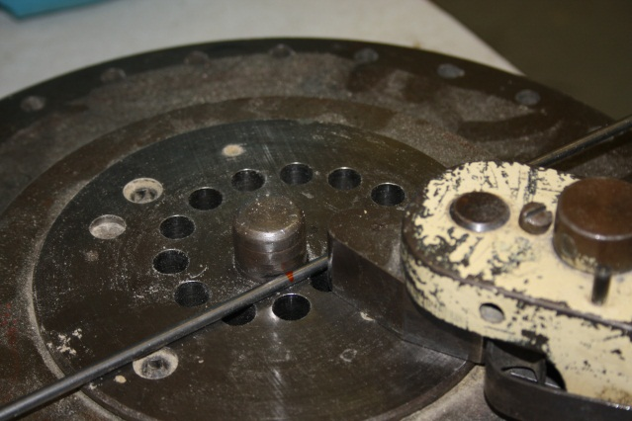
6. Place the first mark (5” from end) against the post of the diacro bender. Tighten it in place with the cam lock.
Long end of 5” mark is here on the nose side

Put cam lock in this hole to tighten metal against the post

7. As you will be bending the long end around the 1” dia post, sure the nose is behind the metal so you can bend it. Keep metal flat on the platen as you bend it.
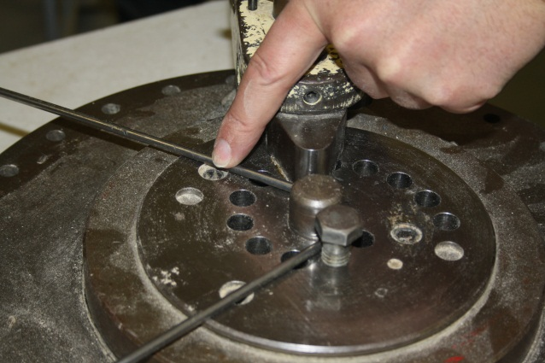
Metal is flat on the platen as you bend
Nose is behind metal to bend it around the post.

8. Bend metal around post so that it is parallel, Metal will spring back slightly so oyu can go a little beyound the parallel mark

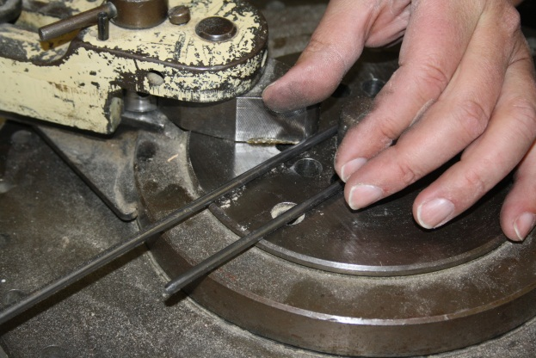
9. Set the 15” mark against the post and bend it about 25 degrees (There is a mark on the bender). Again, make certain that all of the metal (including the point that you just bent) is flat on the platen
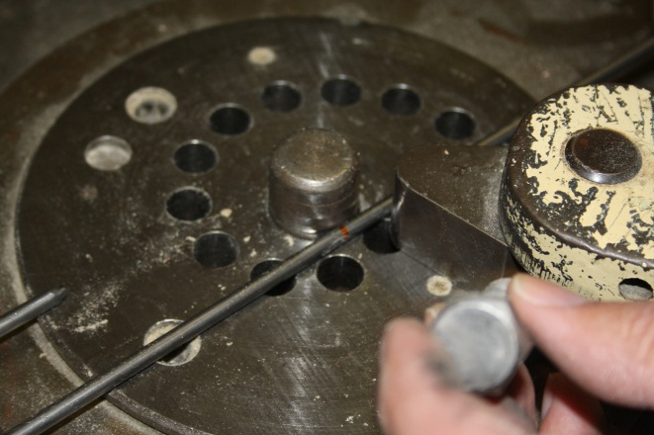
Metal is flat on the platen as you bend

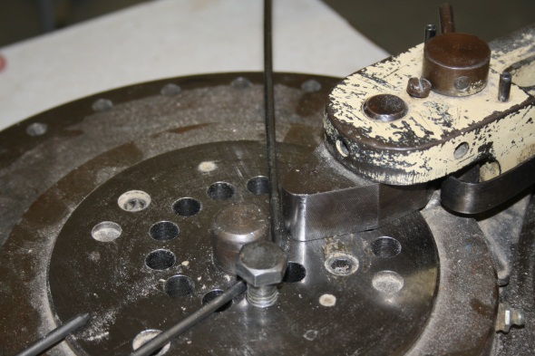
10. Place a straight edge along the “hot dog” 5” portion and mark where it aligns with the newly bent rod. About 1cm will be used up in the bend so mark it 1cm “higher” than where it is aligned.
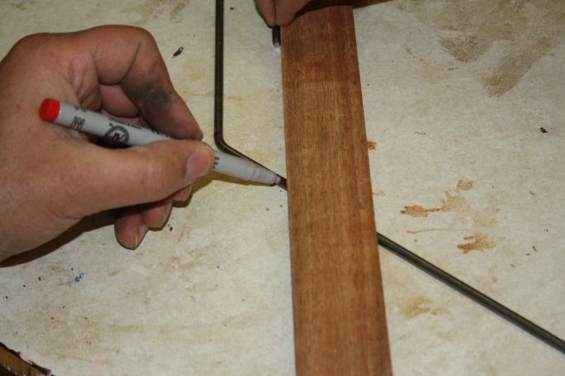
Straight edge aligns with 5” part

Mark it up 1 cm away from the straight edge
11. Bend at this mark back 25 degrees so that the main rod and 5” hot dog area are lined up.
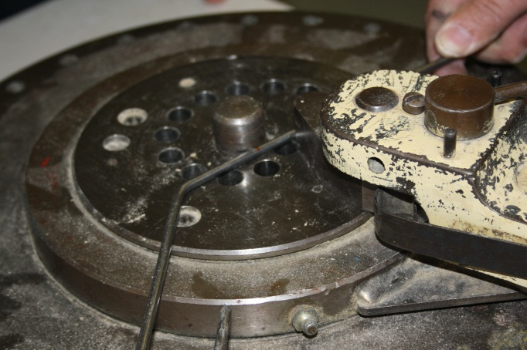
12. Assembly Time. You now need your completed Handles.

Hot Dog Stick Handles
(Only two students can be on the lathe at a time. Do not cut your material in advance as it will dry too much before you turn it.)

- Cut a small diameter birch trunk to 10-11” long using the Bow saw. Remember to use long fluid strokes. Secure the tree in the vice or get a helper to “sit on it” while cutting.
- After putting your Bow saw and measuring tools away, secure your material in the lathe.
- center the front in the headstock
- slide the tailstock into the center of right end. (make sure it is unlocked to slide it)
- Lock the tailstock in place
- Turn the tailstock handwheel to tighten the material into the lathe.
- Slide the tool rest as close to the material without it hitting as it turns. Rotate your material to make sure it doesn’t hit.
- Get Mr. Bain to check your set up and help you get started if this is your fist time on the lathe.
- Use the roughing gouge to turn your material down to about a 1½ inch diameter.
- Use the parting tool to cut in (part) each end 10” apart, measure in 5” and part in at the center.
- Use the spindle gouge to round over the ends and smoothen the straight parts.
- Let your material dry until next class.
- Start the next class sanding your handles while the “new lathe workers” cut their material to length.
- Cut the ends and center of your two handles using the bandsaw. When cutting cylinders on the bandsaw the downward force of the blade will try to turn the material forward in your hand. Guard against this by holding your material firmly.

- Put the ¼” drill bit into the drill press. Secure your handles in the pen vice (make sure the pen vice is clamped securely to the drill press table). Drill into each end so that the holes align going all the way through.

- Finish making your hot dog stick rods as you are now ready to assemble.
Assemble your Hot Dog Stick
- Slide both handles onto the rod.
- Placing the two handles about 2cm from the non-hotdog end, make sure the hot dog end is straight up and down.
- Keeping the inside handle aligned with the rod, bend the outside handle straight down about 15 degrees.
- You can now remove the outside handle but the inside handle is can slide up and down the shaft of the rod.
- Thread the end of the hot dog stick so that you can put a lock nut on to hold the outside stick on.
  - Get the tap and die set
  - You need the #10 x 24 die in the die holder
  - Holding the die perpendicular to the rod, turn the die onto the rod about 1 ½ revolutions
  - Once you have the die “started” onto the rod, turn it about ½ of a revolution at a time, then turn it back to break off the cut metal. Continue this until you have threaded about 1 ½ cm down the rod.
- Slide the second handle back on the rod. Thread a lock nut onto the end to hold it in place. Make sure the nylon end of the locknut is facing to the outside (the nylon is the part that locks so it will not turn itself off the end of your stick) and has about 3 mm of thread beyond it.

