Name _____________________________ Class ________ Date Due_______________

Challenge | Box with Engraved Lid | Grade | Seven
Essential Question | What are the tools and processes used by carpenters, cabinet makers and other construction workers to layout, cut, router and assemble a project. | Estimated Time | 12 Hours

Challenge Description | In this challenge you will begin with a scaled orthographic technical drawing of a box. You will determine dimensions and layout and cut the pieces to size. You will use a router to machine an intricate edge along the top and bottom and the power sander to size your pieces. You will assemble them with glue and clamps. You will learn painting processes and will be able to engrave the top using a CNC “Carvewright” machine. You will install hinges to attach the lid.

Collaboration: Working with others is an important and required part of CTF. When you work with other people, what do you expect them to contribute?

__________________________________________________________________________________

What is your role as a collaborator on this project? ________________________________________

Technical Drawing Infomration
Design: Create a technical drawing of the Format Page

“Technical drawing is a means of COMMUNICATING INSTRUCTIONS and INFORMATION to people to help them make or build things.” “Some technical drawings give general information about what the object looks like, others give precise information about the size and shape of an object.”
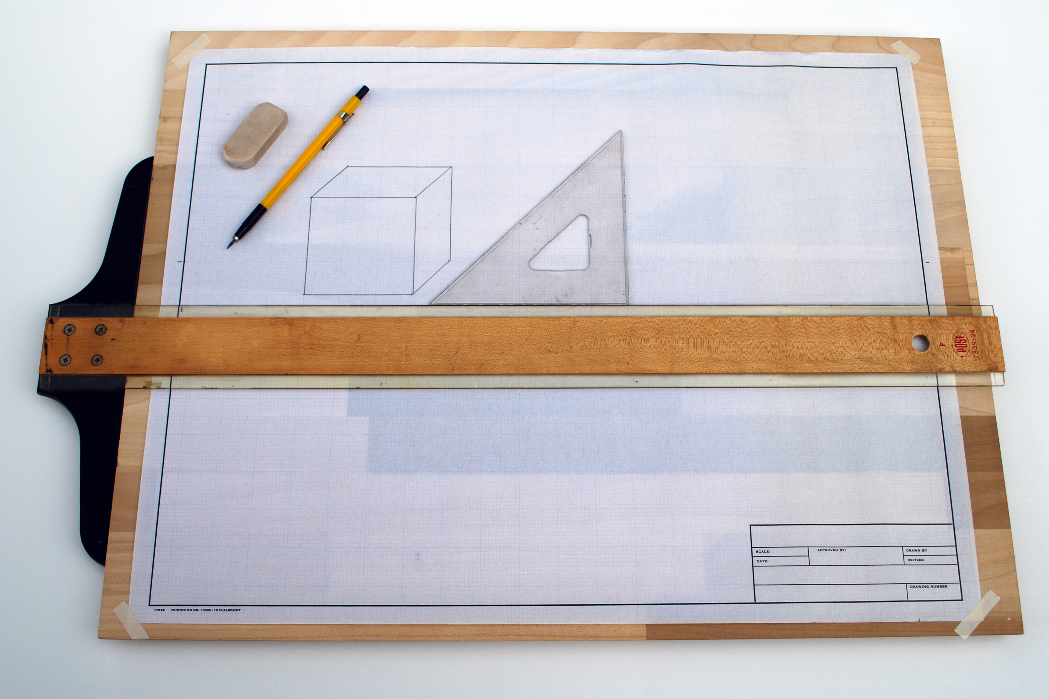
A Quality technical drawing has:
Lines: that are thin and dark. They are crisp looking. It has the proper lines darkened; construction lines and guidelines are light.
Letters: that are properly formed. They are vertical and just touch the guidelines.
NEATNESS: Smudge free and mark free drawings can be made by:
a. keeping instruments clean
b. Drawing lines light first, darkening in later.
c. Erasing completely using an erasing shield.
CORNERS: That are sharp, not overlapped or underlapped. They are not made freehand.
ACCURACY: To within One Millimetre of its actual size.

Lettering

The lettering font used on all technical drawings is gothic. It is a style of lettering that is easy to read.

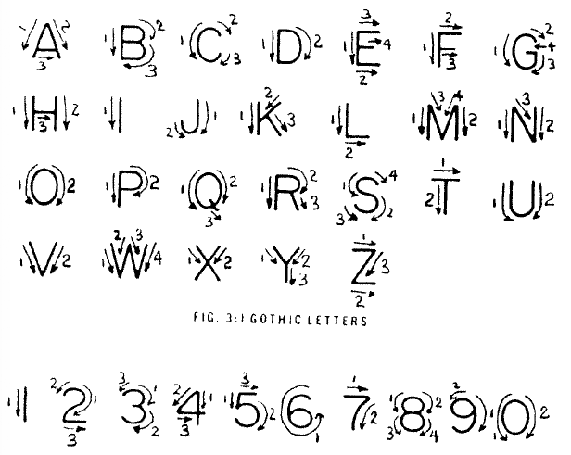
Lettering Hints
- Light guide lines should always be used to maintain uniform height and proper spacing between lines of lettering.
- Letter freehand.
- Always use capital letters.
- Take your time. Letter carefully.
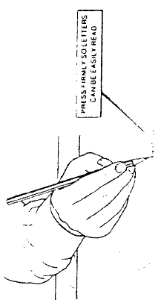
- Spacing between words is a matter of judgment and will improve with practice. Try to space words for easy reading.
- Do not attempt to erase guide lines.

During the initial learning period, make a point of concentrating on hand control and forming letters according to the practice sheet.

- Get a drawing board, T-Square, Scale, Paper and Tape. Sharpen your pencil
- Tape your page down square to the drawing board. Make sure the head of the T-Square is FULLY against the edge of the drawing board when lining up your page. Use about 1 cm of tape on each corner.
- Accurately (within 1mm) measure a 10mm border around each edge.
- Draw light line in a single stroke….pull your pencil toward your hand.
- Draw three more EXTREMELY light guidelines up from the bottom border for a title block. They are 5mm apart
- Divide the title block into three equal sessions (measure across from the left border 86 mm) draw light lines across the title block only
- Darken the border lines, top line of the title block and short division lines. KEEP PENCIL SHARP. Lines should be thin and dark
- In the first section of the title block put your first initial, then your last name eg. K. BAIN all capital gothic letters. Letter between the light middle guidelines. In the second section write FORMAT and the DATE in the third section. 2016/10/28

Begin your Box

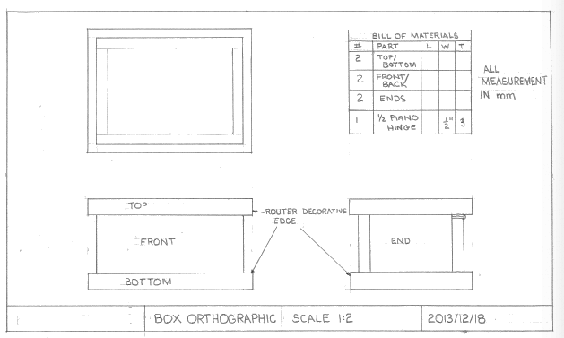
1. Get a technical drawing of the box from your teacher. It will show a box in three views; top, front and side. It is drawn to a 1:2 scale meaning that every cm on the drawing represents 2 actual cm. The length of the box top on the drawing is 10cm, there for it will be 20 cm long on your box. Write 20 cm as the length in the bill of materials. Fill in the rest of the dimensions in the bill of materials by measuring the drawing and doubling the measurement.

Material to Start With:
- Length of ½” MDF that is 70 mm wide
- Length of ¾” MDF that is 150 mm wide

- Measure carefully…label each piece…..draw 90 degree line with a combination square….cut to length using pull saw to within 2mm….sand to length on belt or disk side.

As you work you will learn how to correctly use: A combination square, steel rule, pull saw and miter box, power sanders, router table, clamps, painting, carvewright system, using compressed air. These need to be demonstrated by your teacher.
