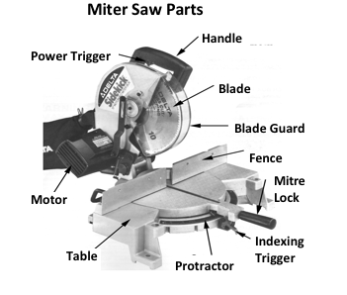 **Miter Saw Use**

**MITER SAW**

Miter saws are used to accurately cut boards to length. They can be set to cut precise angles for miter joints. Equipped with a blade with several teeth on it’s circumference, the miter saw will produce a very smooth, finish cut. A Miter saw is **not** designed to make ripping (with the grain) cuts

**Proper Dress**

l. Wear Eye Protection.

2. Remove jewelry. Confine long hair. Eliminate loose clothing.

**Machine Set-Up**

3. Unplug the miter saw when changing blades and making adjustments

4. Make sure all guards are in place and work properly by retracting as you pivot the blade down.

5. Place support blocks under long pieces.

6. Always make sure the dust extraction system is running.

7. Line up the edge of the blade carefully. Use the clamp if possible.

8. Set up a stop for multiple cuts.

**Operation**

8. Make sure the blade is not contacting the work pieces before switching it on.

9. Do not lower the miter saw until the blade reaches full speed.

10. Feed the blade at a slow consistent speed to produce a smooth cut.

11. Use one hand to guide the saw down through the stock. Use the other hand to hold the stock against the fence. Keep both hands away from the cutting line, out of the 10 cm margin of safety

12. Never reach across the path of the blade.

13. Stand slightly to the left of the blade when guiding the saw with your right hand,

14. Keep your eyes on the cutting edge of the blade while cutting.

15. Cut only one piece of wood at a time.

16. Make sure others are at least lm away from you when operating the Miter Saw

**Finishing**

17. Hold the blade down in the table groove until it comes to a complete stop.

18. Cleanup any scraps that could vibrate into the blade path.