**Grande Prairie**

**Public Schools**

**Junior High**

**Industrial Education**

**Student**

**Safety Passport**

Name _____________________

School _____________________

Grade 7 Year : ______

Grade 8 Year : ______

Grade 9 Year : ______

Created by Industrial Arts PLC

Grande Prairie Public School Board

**Contents**

A Safe Attitude . . . . . . . . . . . Pg 2

Emergency Procedures. . . . . . . . Pg 3

Safety Map. . . . . . . . . . . . . . Pg 4

Wear the Gear. . . . . . . . . . . . Pg 5

ABCs of Safety. . . . . . . . . . . . Pg 6

Power Tool Safety. . . . . . . . . . Pg 7

Know Hazards. . . . . . . . . . . . . Pg 8

Student Contract. . . . . . . . . . . Pg 9

Parent Letter. . . . . . . . . . . . . Pg 10

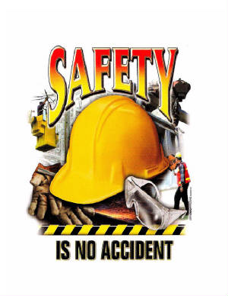

**A Safe Attitude**

**Safety is always important,** especially when you work with power tools. Machines turn sharp saw blades and cutters at high speeds. Accidents happen so quickly the operator seldom knows what happened. Most accidents are caused by workers who lack the right safety attitude. Workers who do not take safety seriously. Instead of working **the safe way**, they work the **fast or easy way**. Instead of being safe, they put everyone in danger.

Machine safety is up to you. Develop a **safe way is the best way** attitude. Learn all you can about the safe operation of each machine. Listen and watch closely as your instructor demonstrates how to use a machine. Know all the safety rules and the steps for operating each tool.

To operate a machine safely, you must know more than just how to turn it on and off. You must know how to do the basic operations and how to make simple adjustments. You must know the machine’s limits. Keep the machine at a safe, steady speed. Use the machine for the operation it was designed to do.

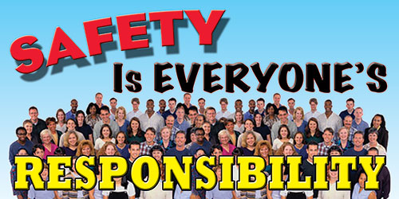You cannot expect to be an expert on all machines right away**. DO NOT EXPERIMENT**. If you have a question, ask your instructor. The more you know about a machine, the safer you will be. A machine only does what its operator directs it to do. It can only be as safe as its operator. As you learn to operate a machine, you will gain confidence. Make sure that confidence does not lead to carelessness. This does not mean you should be afraid of machines**, a safe attitude is one of respect**- respect for what machines can do.

**Emergency Procedures**

**A. Fire Alarm**

1. Remain Calm
2. Turn off any machines and lab power button
3. Store any tools safely on tables and benches
4. Exit in orderly manner through rear door, assemble in area at end of driveway near the dumpsters
5. Stay with your class as the teacher takes attendance and sends it to the front of the school with a student.

Note: If you are out on a photo or video assignment, hurry over to join the class in front of the IA room as quickly as possible.

**B. Lock Down**

1. Remain Calm
2. Turn off any machines and lab power button
3. Store any tools safely on tables and benches
4. Go to upstairs classroom. Get a magazine to read and sit on the floor along front under the whiteboard. Remain silent and still until your are given further instructions.

Note: If you are out on a photo or video assignment, find a suitable place to hide until you hear further instructions via the intercom.

**C. Accident**

1. Remain Calm
2. Get first aid kit
3. Call the office (Secretary, dial 2300 (Michael Jordan/Lebron James with two zeros) give instructions “we have had an accident in the shop, we need assistance”
4. Emergency Response Team, in place. Your task is : _______________________________
5. Stay out of the way
6. Be available; Await further instructions.

Page 3

**Safety Map**

On the map of the Alexander Forbes Industrial Arts Lab, Indicate the following with the letter that corresponds to the safe location

a. Emergency Power shut offs (x4)

b. Fire Exit

c. Fire Alarm Pull Station

d. Fire Extinguisher (x3)

e. First Aid Kit

f. Eye Wash Station

**Wear the Gear; PPEs:**

***Arrive in Style, with your I.A. Fash-On***

1. Wear Eye protection the Lab

2. Wear Shoes. (Rubber Soles, no sandals)

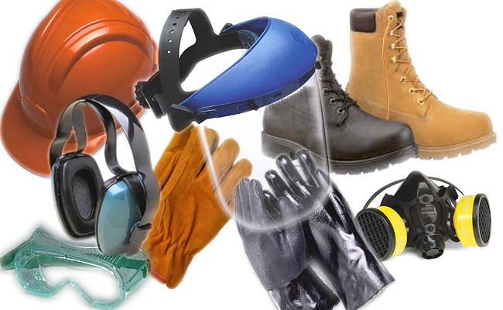3. No Loose clothing (remove hoodies with laces, long sleeves rolled up, baggy gets tucked)

1. Tie back long hair.

5. Remove unsafe jewelry (Rings, bracelets, necklaces, dangly earrings)

6. Hearing protection is available.

7. Particle Dust masks will be provided as required.

8. Aprons are provided for students to wear to help protect clothing, however it is advised that students do not wear their best clothing on days they have industrial arts as snags, rips and drips can happen. *T-Shirts and jeans make a good fashion statement in the Jr. High industrial arts lab.*

Page 5**Know your ABCs: (Always Be Careful)**

*Safety is an* ***attitude.*** *Knowledge is not enough. You must make a* ***conscious*** *decision to* ***ALWAYS THINK SAFETY*** *and direct all actions towards making the industrial arts environment a safe and productive one.*

9. NEVER fool around, run, or throw things.

10. Always keep your mind on your work- do not daydream

11. Carry tools appropriately. (Saws point down, no sharp tools in pockets etc.)

12. Stay in your area, respect people's workspace, avoid Crowding.

13. Do not distract others who are working on machines.

14. Keep your work area tidy. Put tools away as soon as you are finished using them. Clean up your scraps before leaving a machine.

15. If you think you see something dangerous, tell your teacher or fix it, but NEVER leave it.

1. Report any accident, no matter how minor, to your teacher.

17. Common Scents: - Be alert for any odors that might indicate overheating of the machine or stock. If anything unusual happens, turn off the machine immediately. If the machine does not sound right, turn it off immediately. As soon as it stops completely, check with your instructor.

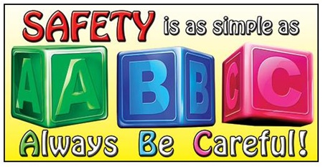

**With Respect for Tools and Equipment**

18. Before using equipment, students must:

a. participate in the teacher's safety demonstration on the machine.

b. obtain mastery on a written machine safety test.

c. obtain permission and demonstrate proper use to the teacher before using it for the first time.

19. Stand in a comfortable, balanced position when working with power tools. Both feet should be firmly on the floor.

20. Do not use the machine until it is operating at full speed.

21. When someone is operating a machine keep at least one metre away from them.

22. If you leave your machine, even for a short moment, turn off the power and stay with it until it comes to a complete stop.

23. Make sure all safety guards are in place. Have your instructor check new setups before you begin.

24. Keep the machine clean. Remove all tools, lumber, and unnecessary materials. Objects left on the machine can vibrate into revolving cutters. They can then be thrown from the machine with great force. Never clean a machine while it is running.

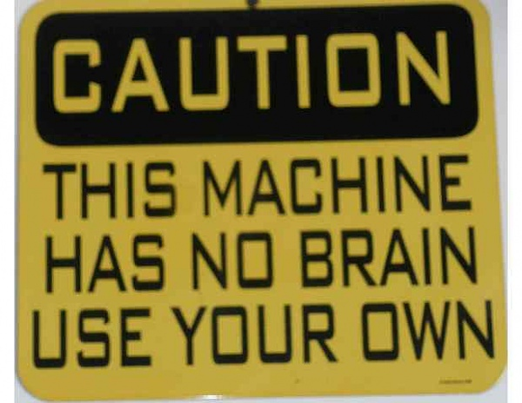

25. Always keep your hands a safe distance from cutters and blades.

26. Always keep your eyes on the cutting action. Concentrate on what you are doing at all times.

Page 7

**Know Hazards: No Hazards:**

27. Defects in the wood can be dangerous. Check the stock carefully for knots, splits, and other defects.

28. Report any broken or inoperative tools to your teacher. (Frayed Cords, broken or missing handles, loose hammer heads)

29. Know where all fire exits, alarms and extinguishers are and how to use them.

30. Know where all safety stop switches are and how and why to use them.

31. Students are not to turn on the main lab power switch.

32. Before you plug in a machine, make sure the switch is in the **off** position. You do not want the machine to start unexpectedly.

33. Always direct compressed air away from body parts

1. 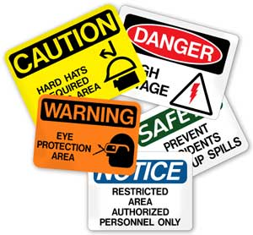 Rags and paper towels that have been used to wipe on flammables must be placed in a garbage can with a lid.

35. Keep power cords away from blades and cutters.

36. Students will not use any power equipment if a qualified CTS teacher is not present.

*Is the biggest* ***Hazard*** *in the shop between your ears? Page 8*

**STUDENT SAFETY CONTRACT**

* I have read and understand the safety rules. I will follow them to ensure my own safety and also the safety of others in the industrial arts laboratory.
* I will conduct myself in a responsible manner to avoid accidents and to provide a safe learning environment for everyone.
* I understand that if I do not follow all the rules and safety precautions, I will not be allowed to participate in industrial arts activities.
* I agree to follow the teacher’s instructions.
* I will help to keep the lab a safe, tidy and productive environment.
* I will show the care, determination and persistence to produce my best quality work.
* I will solve problems and check with the teacher to get feedback on my solutions.



Student Signature___________________________

(Gr. 7) Date _________________________

Student Signature___________________________

(Gr. 8) Date _________________________

**Page 9****Dear Parent or Guardian:**

The industrial arts facility at Alexander Forbes School is a safe and productive workplace. We appreciate your support in maintaining this environment and encourage you to review the safety procedures and discuss the importance of a safe attitude with your child. We encourage you to visit the industrial arts lab during meet the teacher night. Your child will be permitted to perform industrial arts activities once this document is signed by both the student and parent, making you aware of the measures taken to provide a safe, fun and productive learning environment.

Parent Name _______________________ Phone # ______________________

Signature___________________

Date ___________________

*Important questions:*

Does your child wear contact lenses? Y or N

Is your child color blind? Y or N

Please list any allergies or medical conditions that the teacher should be aware of:

___________________________________________________________________

____________________________________________________________________________________________________________________________________

Emergency Contact Name________________________

Phone Number_______________________

Page 10