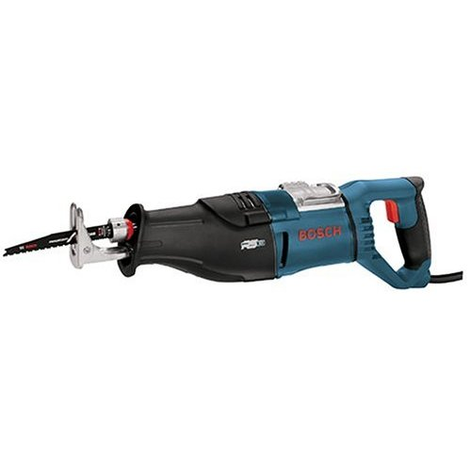
Portable Electric Power Tool Safety
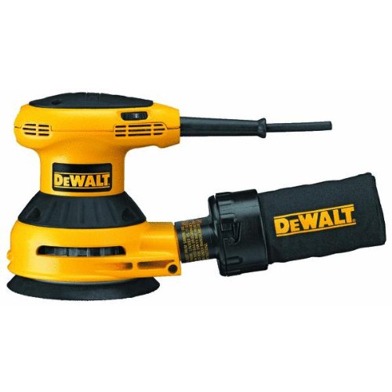
Portable electric drills, sanders, grinders, routers, circular saws, reciprocating saws or jigsaws are used for specific jobs in the CTS Lab. Most accidents from using these tools result from using the wrong tool for the job, using the tool incorrectly, failing to wear personal protective equipment, or failing to follow approved safety guidelines.
Set Up
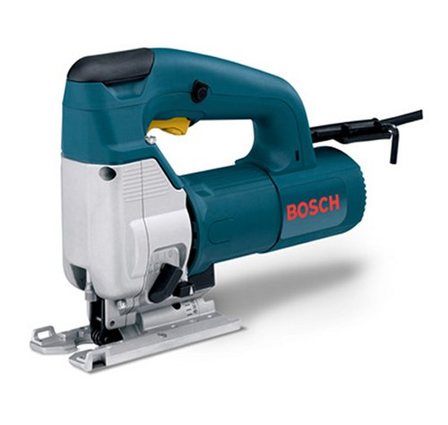
- Choose the right tool for the job. Only use a tool for the specific task it was designed to do. Check with your teacher or the owner’s manual for specific precautions to take while using the tool.
- Maintain tools with care; keep them sharp and clean for best performance.
- Unplug tools when not using them, cleaning them, and when changing accessories such as blades, bits, and cutters.
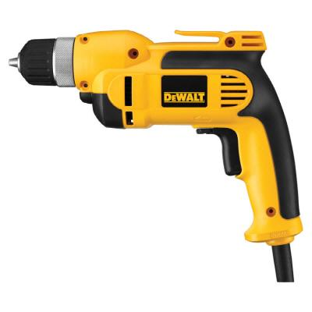
- Protect the cord and plug. Never disconnect power by pulling on the cord--remove the plug from the outlet. Report any defective or broken plugs and insulation around the cords. Keep cords away from heat, oil, and sharp edges.
- Do not wear rings, jewelry, or loose clothing when operating power tools.
- Wear Personal Protective Equipment (PPE), such as face shields, safety glasses, disposable masks, etc. as required.
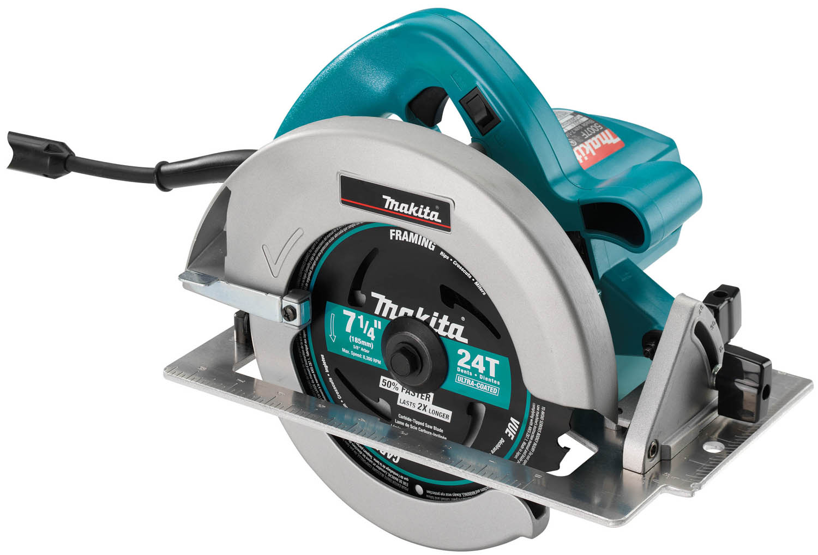
- Use tools in well-lit areas. Do not use electric tools in damp or wet.

Tool Operation
- Avoid accidental starting. Before plugging or unplugging tools, be sure power switch is turned to "OFF." Do not hold fingers on the switch button while carrying a plugged-in tool.
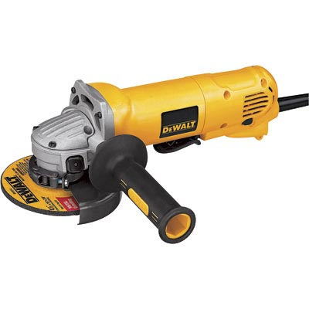
- Plug in your tool in a receptacle that does not stretch across a walk space, creating a trip hazard.
- Keep your balance and proper footing when working with power tools. Be careful not to over reach.
- The area where you're standing shouldn't be slippery or cluttered. Cluttered areas and benches invite accidents.
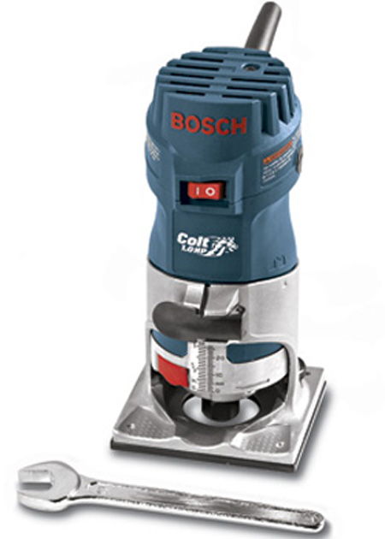
- Use tools on a stable work surface. Hold the work with a vise or clamps whenever possible.

Finishing Up
- Put tools away in a dry place when not in use. Never leave them on a ladder, scaffold, or overhead workspace. Keep them where they won't fall on someone or trip someone.
- Carefully wind and store cords to prevent over bending or breaking of the wires inside the cord.
Pneumatic Tools
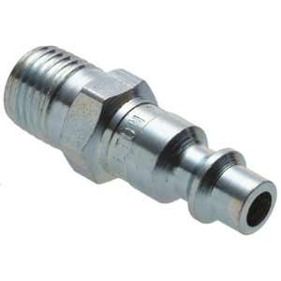
Pneumatic tools are powered by compressed air. Common types of these air-powered hand tools that are used in industry include buffers, nailing and stapling guns, grinders, drills, jack hammers, chipping hammers, riveting guns, sanders and wrenches.

Do not aim compressed air at any part of your body
a. Air forced into the tissues or blood stream via pores of your skin can cause an air embolism which can be fatal if it reaches the heart, lungs or brain
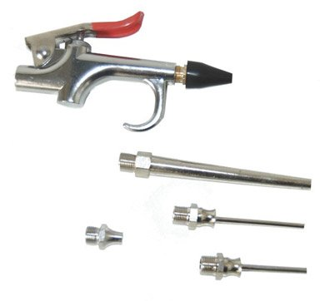
b. Air blown into the mouth can at 5psi rupture the esophagus or the lungs
c. Eye and ear injuries can occur from a blast of air or flying particles. 40 psi can blow out an eardrum and 12 psi can blow an eye out of its socket.

Set-Up
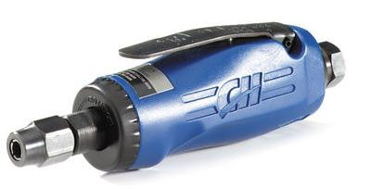
- Turn off the compressed air at the valve before connecting tools. Turn and pull slightly outward to make sure it the tool is properly seated before turning on the air.
- Check hoses regularly for cuts, bulges and abrasions. Keep the air hose away from sharp edges, heat and oil. Use air tools near hose connection to eliminate a trip hazards.
- Eye protection is required, and head and face protection is recommended for employees working with pneumatic tools.

Tool Operation
- Pneumatic tools that shoot nails or staples must be equipped with a special device to keep fasteners from being ejected, unless the muzzle is pressed against the work surface.
- A chip guard must be used when compressed air is used for cleaning.
- Do not carry a pneumatic tool by its hose.
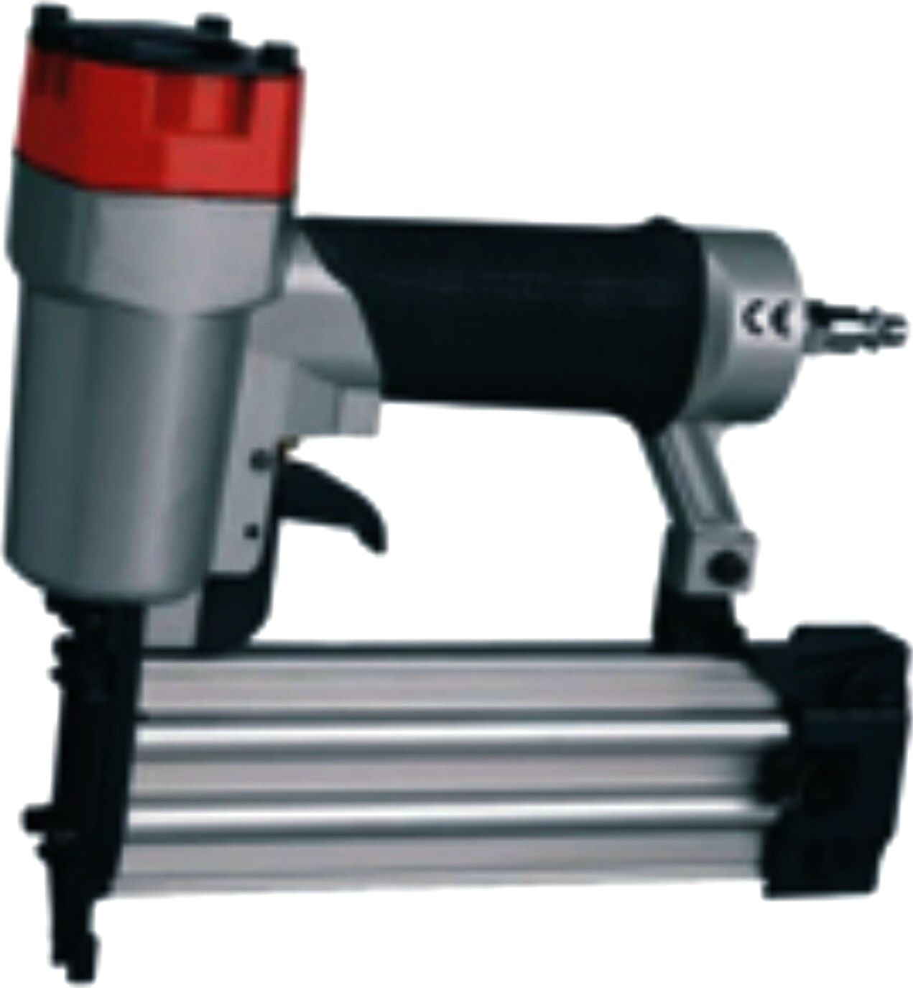
- Do not use compressed air to blow debris or to clean dirt from clothes. When blowing off machines, the nozzle pressure MUST remain below 207 kPa (30 psi).
- For staplers and nailing guns, keep the gun square to the work. Aim the staple or nail properly and be aware of co-workers nearby or underneath your work area.

