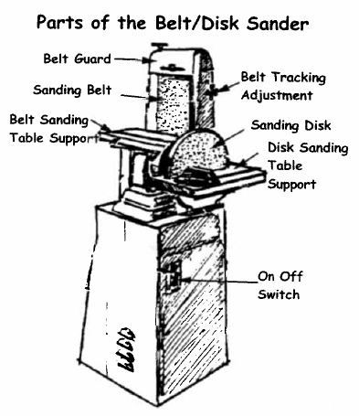
Power Sanders Use
P
O
W
E
R
S
A
N
D
E
R
S
Sanding machines make sanding fast and easy. You can safely sand convex curves and straight lines using the belt or disk sander.
The drum Sander is used to sand concave curves. Power Sanders do not create a finished job, they are no a substitute for hand sanding to produce a smooth finish on your project.

Proper Dress
l. Wear Eye Protection.
2. Remove jewelry. Confine long hair. Eliminate loose clothing.

Machine Set-Up
3. Make sure all guards, including the top belt guard, are in place.
4. Check that the sanding drum is not “riding” up the rubber sleeve. Do not operate a sander with a torn belt or loose disc. Make sure the belt is “tracking” properly before sanding.
5. Always make sure the dust extraction system is running and the blast gate is open when sanding.

Operation
6. Do not use the sander until it reaches full speed.
7. Always keep your wood supported on the table in a way that it cannot “tip” into the sander. Do not lift the wood up off the table when sanding.
8. Always sand on the downward (left) side when using the disk sander.
9. Use slight even pressure pushing the wood even with your line. Keep your eyes on the sanding surface and stop when you get to your line.
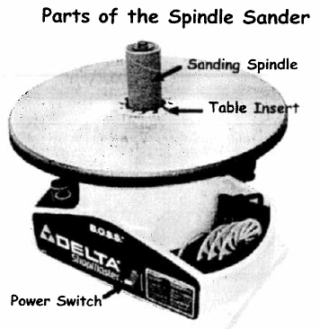
10. Work from left to right into the rotation of the spindle sander.
11. Keep a margin of safety of at least 5 cm between your hands and the spindle, belt or disk when sanding.
12. Keep the wood moving to prevent burning while sanding.
13. Make sure others are at least lm away from you when operating the Power Sanders.

Finishing
15. Stay with your machine until it comes to a complete stop.
16. Tidy your machine before leaving it.

