**Scroll Saw Use**

**SC**

**R**

**O**

**L**

**L**

**S**

**A**

**W**

The scroll saw is used to cut very tight curves or “Scrolls” in thin wood, plastic or soft metal. Internal cuts can be made on the scroll saw by drilling a small hole, then inserting the blade through the hole to cut irregular shapes out of the inside of the wood.

**Proper Dress**

l. Wear Eye Protection.

2. Remove jewelry. Confine long hair. Eliminate loose clothing.

**Machine Set-Up**

3. Use a blade suitable for the job you are doing. Eg. Use a metal cutting blade for aluminum. **BEFORE INSTALLING A BLADE, UNPLUG THE SCROLL SAW.**

The blade is held in place by the thumbscrew blade clamps attached to the top and bottom arms of the scroll saw

1. Make sure the blade tension lever is moved fully to the right
2. Loosen, but do not unscrew, the top and bottom thumbscrews.
3. Thread the blade through the hole in table, with the teeth facing toward the front of the saw. Scroll saws cut on the downstroke, so it is essential that teeth face forward and down.
4. Insert the blade into the bottom blade clamp and securely tighten the thumbscrew by hand.
5. Insert the top of the blade into the top blade clamp and securely tighten the top thumbscrew.

f. Move the blade tension lever to the left to increase tension on the blade.

4. Set the hold down so that it maintains downward pressure on the wood to keep it from “bouncing”.

5. Set the speed to a rate suitable for the hardness and thickness of the material.

**Operation**

6. Maintain a margin of safety of at least three centimeters.

7. Do not talk to people while you are using the scroll saw.

8. Feed material into the blade at a gentle rate. Do not push hard as the blade will break, maintain a slight downward pressure to “assist” the hold down in keeping the work from bouncing.

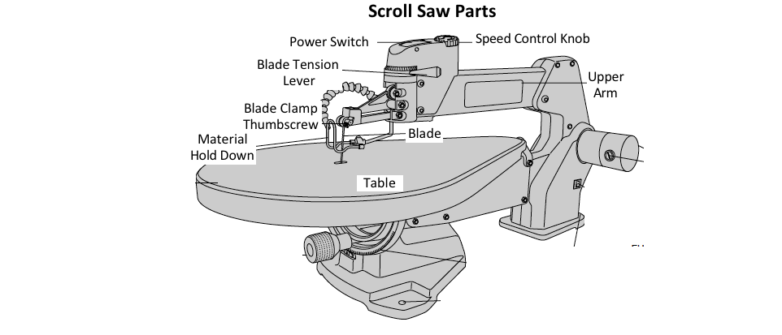9. Turn off the machine and let it come to

complete stop, clean the work area

and lower the hold down before

leaving the machine.

**Finishing Up**

15. Stay with your machine

until it comes to a

complete stop.

16. Tidy your machine

before leaving it.