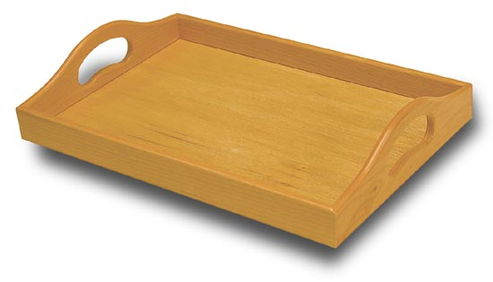
Serving Tray

Bill of Materials
# | Part | Material | Length | Width | Thickness
2 | Ends | Pine | 30 cm | 9 cm | 2 cm
2 | Sides | Pine | 45 cm | 4 cm | 2 cm
1 | Bottom | Plywood | 43 cm | 30 cm | 1 cm

- Locate material for sides, plane to 2 cm thick.
- Locate material for ends, plane to 2 cm thick
- Get Mr. Bain to rip sides to width of 4 cm and ends to 9 cm
- Router a 1cm x 1cm rabbet along bottom edge of each end and side
- Get Mr. Bain to “rabbet” the ends of the sides on table saw, then finish on the bandsaw that is set up for ripping
- Find pattern template for ends, layout shape
- Drill holes for handles as indicated with 1 ¼ ” forstener bit
- Use scroll saw to complete handle cutout, sand to shape using spindle sander (Use the largest possible spindle to find the size
- Cut top contour of handle on bandsaw
- Sand to shape on disk and spindle sanders (use largest spindle)
- Assemble with glue, Do not allow glue to “smear on sides of your wood, only in joint) pin sides to ends. Use clamps to secure bottom in place for minimum of 15 minutes
- Sand using 80 grit, 100 grit and finish with 120 grit sandpaper
- Apply three very thin coats of varathane.

