Name _____________________________ Class ________ Date Due_______________

Challenge | Toy Truck | Grade | Seven
Essential Question | What are the processes and procedures used by Engineers and automakers to design, modify and build innovative new products. | Estimated Time | 12 Hours

Challenge Description | In this challenge you will use the design cycle to construct a Toy Truck. You will begin by creating a technical drawing of the “base” model of the truck. You will layout, drill, cut and sand the base model to size. You will then research plan and build onto the base model to create your own unique Truck design.

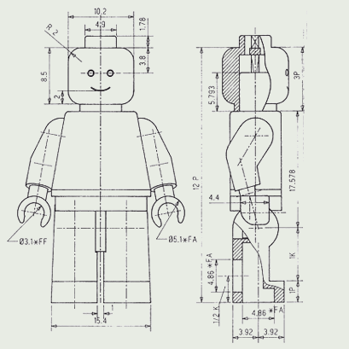
1. The Technical Drawing
Design: Create a technical drawing showing the side view and Top view of the truck

“Technical drawing is a means of COMMUNICATING INSTRUCTIONS and INFORMATION to people to help them make or build things.” “Some technical drawings give general information about what the object looks like, others give precise information about the size and shape of an object.”
Who Uses Technical Drawings?
“Technical drawings are used by all professions which involve designing or making objects. Architects and civil engineers use technical drawings to show builders how to construct a building and what materials to use. Mechanical Engineers use technical drawings to pass instructions to the factory about how to make their designs. Electronic engineers do technical drawings to design circuits and show how to wire something up. Product designers make technical drawings to show clients what their ideas will look like once the product is made.” “Peach, Susan; Technical Drawing: Highgate Press;1987

A Quality technical drawing has:
Lines: that are thin and dark. They are crisp looking. It has the proper lines darkened; construction lines and guidelines are light.
Letters: that are properly formed. They are vertical and just touch the guidelines.
NEATNESS: Smudge free and mark free drawings can be made by:
a. keeping instruments clean
b. Drawing lines light first, darkening in later.
c. Erasing completely using an erasing shield.
CORNERS: That are sharp, not overlapped or underlapped. They are not made freehand.
ACCURACY: To within One mm of its actual size.
Technical Drawing Reminders

- Keep your Pencil sharp for accuracy.
- Tape your page down square with the drawing board. Get a buddy to check it with the T-Square against the edge of the board.
- Format your page with a 10 mm border and a title block with guidelines 5mm apart.
- Use the 1:1 scale and measure accurately. Draw lines lightly at first using your T-Square
- The top view is drawn (projected) directly above the side view.
- Center lines are thin and dark. The “dash” in the middle should be about 3 mm long and the lines should extend beyond the circles by about 2 mm
- Hidden lines are dashes, not dots. They are about 3mm long with about 1mm spaces

- Lettering

The lettering font used on all technical drawings is gothic. It is a style of lettering that is easy to read.

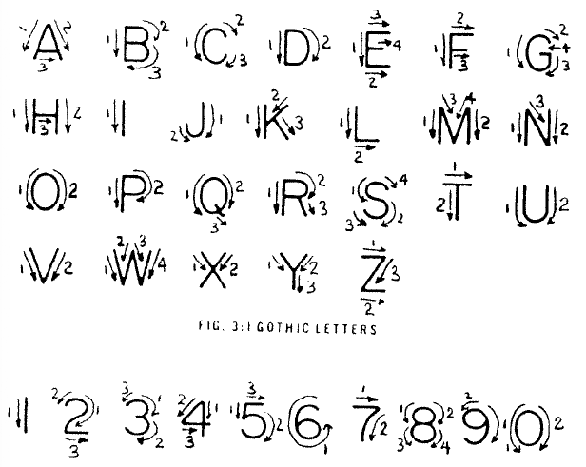
Lettering Hints
- Light guide lines should always be used to maintain uniform height and proper spacing between lines of lettering.
- Letter freehand.
- Always use capital letters.
- Take your time. Letter carefully.
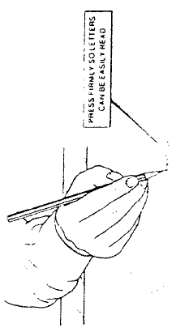
- Spacing between words is a matter of judgment and will improve with practice. Try to space words for easy reading.
- Do not attempt to erase guide lines.

During the initial learning period, make a point of concentrating on hand control and forming letters according to the practice sheet.

2. Create the basic truck shape.
1. Layout
2. Drill holes on drill press (Teacher supervision)
3. Cut contours on band saw (Teacher supervision)
4. Sand to the lines using power sanders (proficiency shown when making box)
5. Hand sand smooth to remove pencil marks and blemishes.
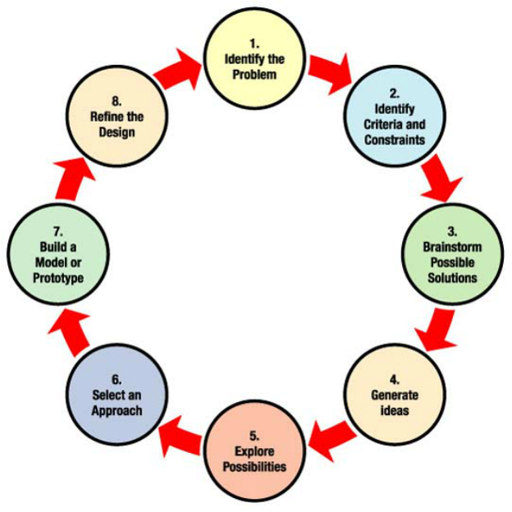

3. Design the Back:
1. You cannot have a solution without a problem!
What kind of toy truck are you planning to make?

________________________________________________

2. Criteria and Constraints
Your truck must fit the base model you have made. Your design can have up to six wheels and should be easy to make.

3 - 5. You need ideas
Search the Internet and find several designs of wooden toy trucks that you like and seem reasonable to make. Sketch or Copy your 5 or 6 favorites and paste them onto a SINGLE page of a word document. Print the document staple it to this design booklet.

- Select an Approach
Which is your favorite idea? ___________________________? Why? ____________________

_____________________________________________________________________________

COOPERATION and COLLABORATION: Find others who are making a similar design to yours that you can work with. Working with others is an important and required part of CTF: Construction and Design.

8. Sketch your solution

Top View

Side View Rear View

9. Present your Solution
Get your friends and teacher to critique your solution

Name Suggestions for Improvement
________________ _____________________________________________________
________________ _____________________________________________________
________________ _____________________________________________________
____Mr. Bain_____ _____________________________________________________
10. Create a Bill of Materials listing the parts required to make your project. Do this in pencil. It is a working document

Part Name | # required | Length | Width | Thickness

Show this to Mr. Bain to communicate your ideas. Make sure you have your internet example to show as well.

4. Build your Design

5. Follow-up
What did you like most about designing your truck? | What part of constructing your truck did you find challenging? What did you do to overcome the problem?
What careers do people who design new products hold? How do they train for that career? | If you could do this challenge again, what would you do differently?
Name some construction trades. How do they train for their career? | Who did you work with that was helpful in designing and building your truck. How did you collaborate with others in your group?
Did your truck “turn out” the way you envisioned? How was it different? | How did you help others?
