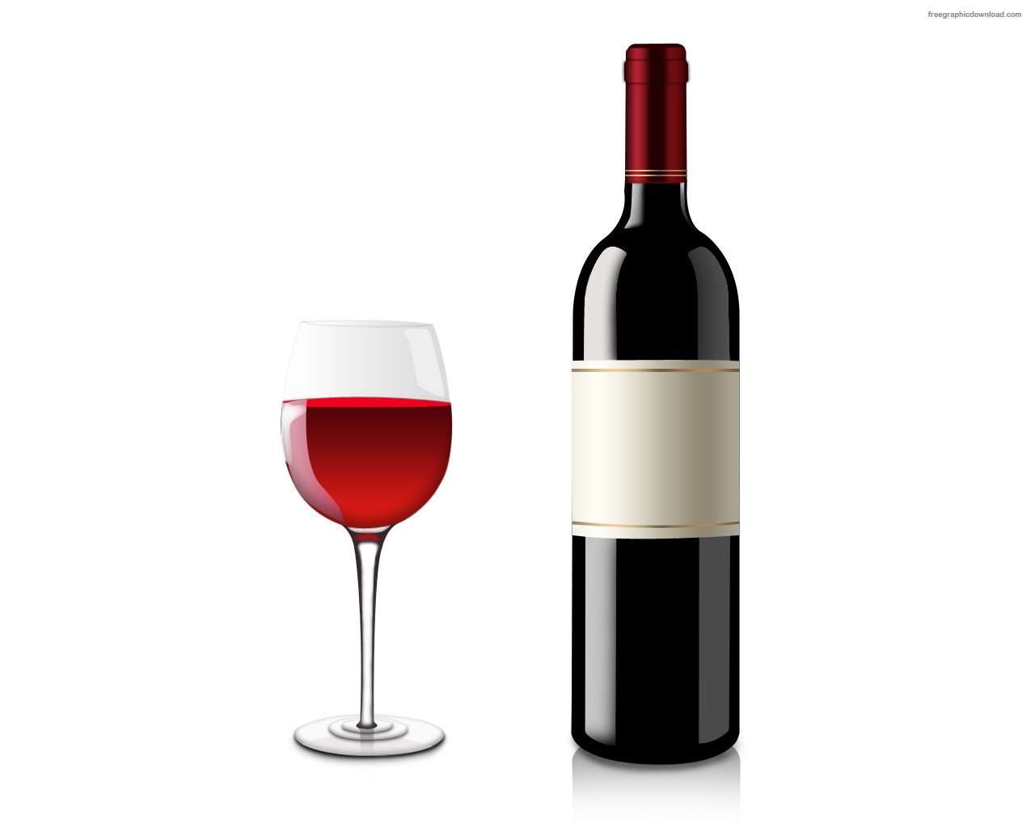
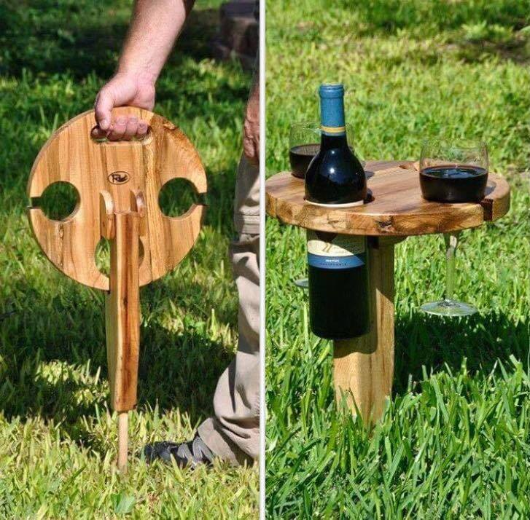
Grade 8 Challenge: Design and Build a Wine Table similar to the one shown

Research: Sizes you will need to know
Height of table from sitting in a lawn chair height
Diameter of a wine Bottle
Diameter of widest part of a wine glass
Diameter of stem of wine glass

Determine the Diameters of the top and write them on the layout shown.
Part C
Part D
Part B
Part A
Bill of Materials:
Part | # of Pieces | Part Name | Lngth | Wdth | Thk
A | 1 | Top
B | 1 | Stake (Leg)
C | 2 | Cleats (Support the Stake)
D | 1 | Pin (to fold top into position)
Process:
Top
- Laminate pieces to make the top (min dia for Planer is 30 cm long)
- Layout all holes in the top
- Drill holes using fly cutter, holes saw or forestner bit.
- Cut out circular top and slits to fit wine glass stems
- Router all edges
- Sand starting with 80 grit working up to 150 grit sandpaper.
Part B
Stake
- Cut the stake to size
- Drill pin hole
- Router all edges
- Sand starting with 80 grit working up to 150 grit sandpaper.
Cleats and Pin
- Cut cleats to size
- Fasten cleats to top
- Drill pin hole
- Insert pin, fasten in place.

